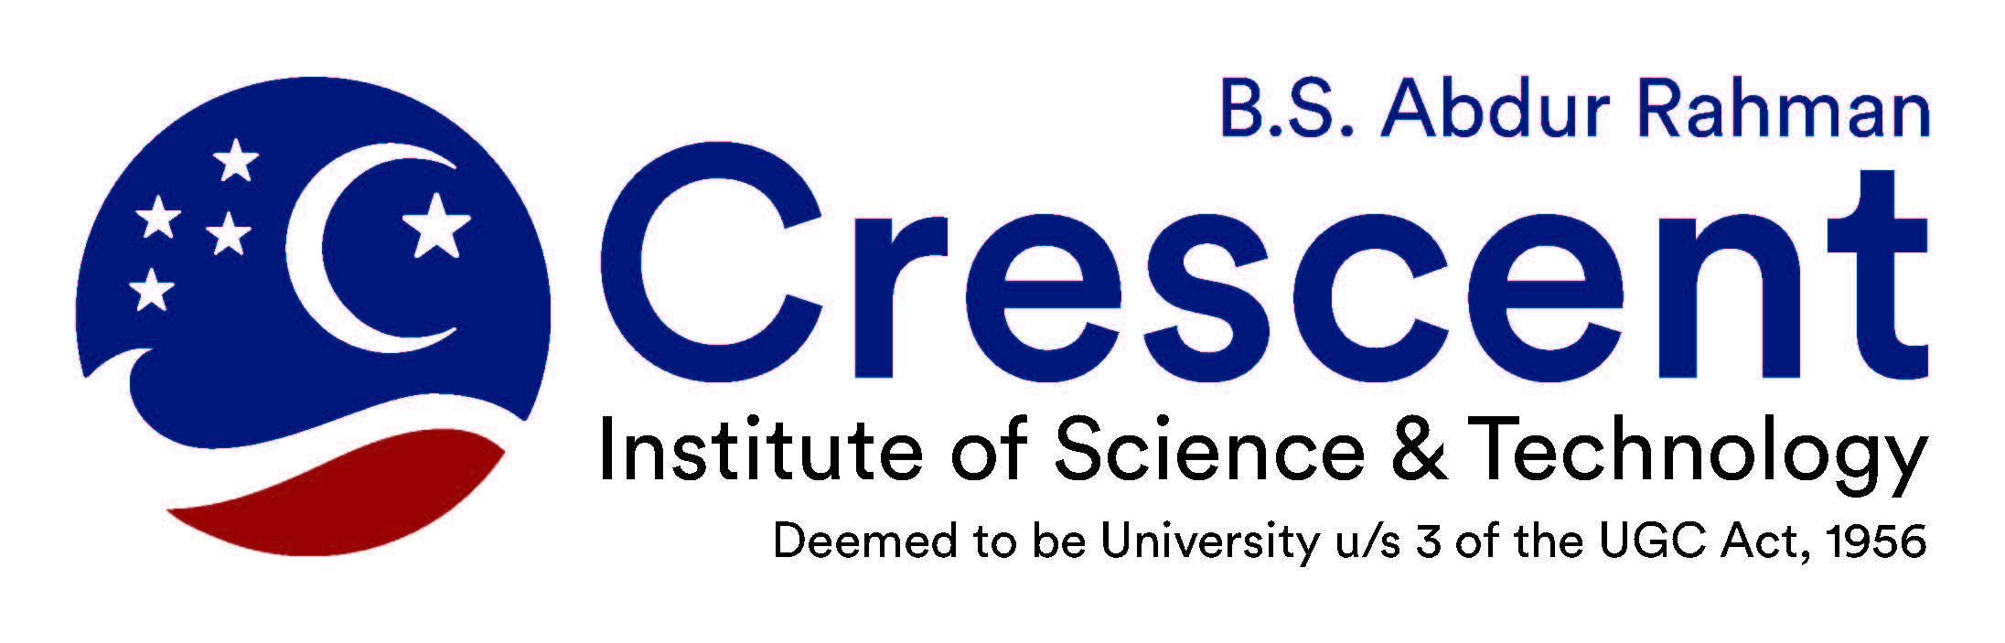

Crescent Innovation and Incubation Centre

REPORT

Intellectual Property Rights (IPR) & Innovation

Dr. M Kantha Babu, Anna University

**Date:** 29.09.2018

**Time**: 10 am to 3 pm

**Venue:** Seminar Hall 3

**About Trainer:**

**Dr. M Kantha Babu,**

Director, Centre for Intellectual Property Rights,

Anna University, Chennai – 600025

9444114691

**Members Participated:**

Deans

HOD

Directors

Professors

Research Scholars

**Background of the Program:**

One –day workshop on “The Art of Writing Winnable project Proposal for funding” is well structured focuses on different aspects of writing effective project proposal that can be easily qualify for approval by any funding agencies. This workshop will bring a positive transformation in the faculty member’s attitude while submitting the project proposals and definite result oriented.

**Highlights of the Program:**

* Funding schemes of Central Government Departments / Agencies of Innovative Research
* Roles & responsibilities of IPR Cell
* Tariff for IPR Services
* Components of Institutional IPR Cell
* Technology Transfer
* Required Budget

**Key points discussions:**

**Snap Shots**

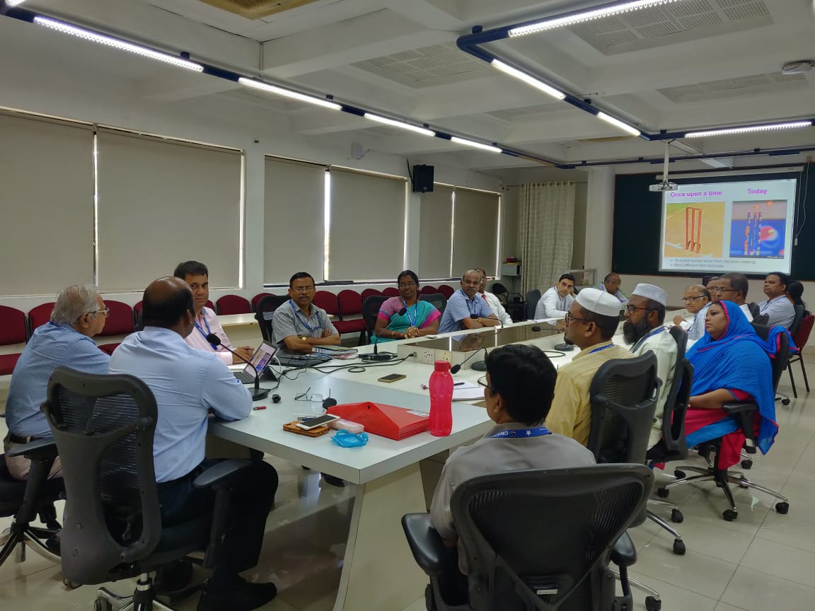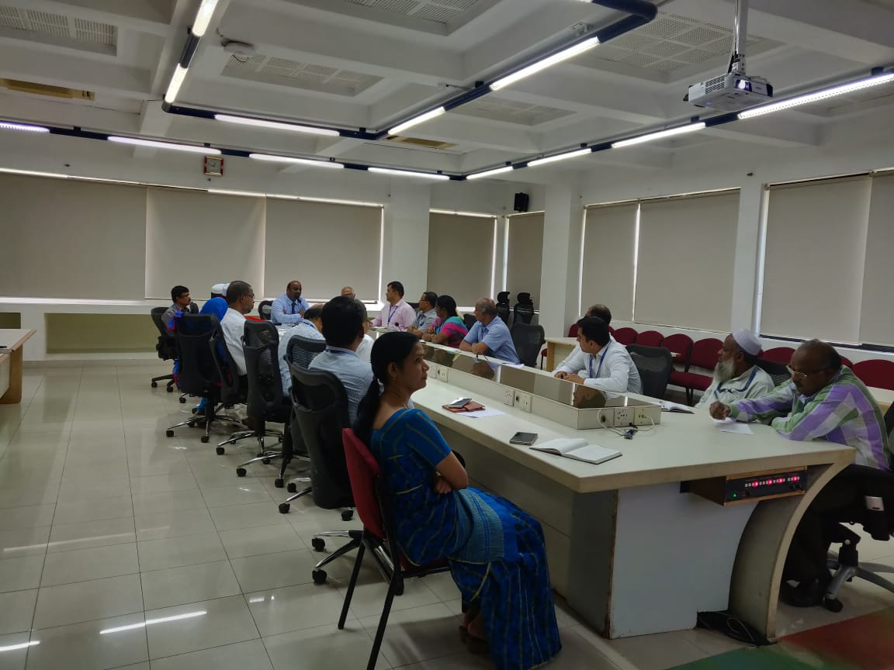

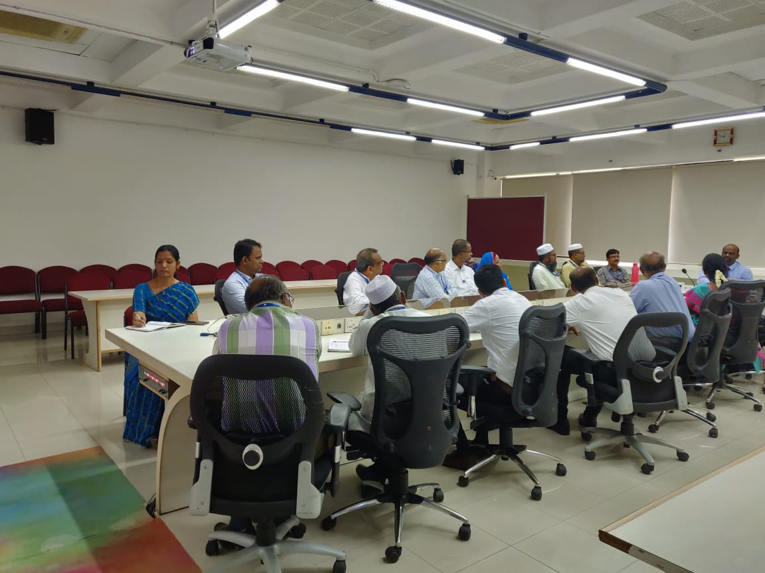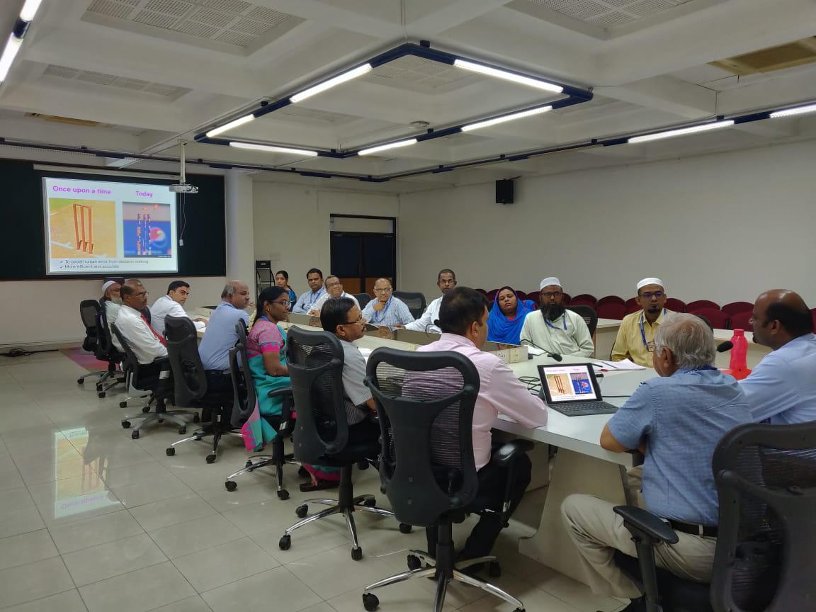

**B.S.Abdur Rahman**

**Crescent** Institute of Science & Technology

**Crescent Innovation and Incubation Centre (CIIC)**

Seethakathi Trust, GST Road, Vandalur, Chennai - 600048Mobile : 95510 76617  
e-mail: ceociic@crescent.education